MACHINE LEARNING BASED EPILEPSY IMAGE DIAGNOSIS SOFTWARE
Abstract
Epilepsy is a chronic neurological disorder marked by recurrent seizures, and early diagnosis is crucial for effective treatment and management. This project presents a Machine Learning-based diagnostic software that utilizes EEG (Electroencephalogram) signals to automatically detect the presence of epilepsy. The system is developed using Python and SQLite, providing a complete web-based interface that enables users to sign up, log in, upload EEG datasets, and receive diagnostic predictions. To train and evaluate the system, we used the publicly available Epilepsy EEG dataset from Kaggle, which contains pre-processed EEG signals categorized as epileptic or non-epileptic. Two popular machine learning algorithms—Support Vector Machine (SVM) and Random Forest—were implemented to classify the data. The system measures the performance of these models using metrics such as accuracy, precision, recall, F-score, and confusion matrices. Experimental results show that the Random Forest algorithm achieved a higher accuracy of 97%, outperforming SVM with 80%. The software also allows real-time diagnosis where users can upload test data in CSV format, and the trained model predicts whether the data indicates normal or epileptic conditions. This project demonstrates the potential of machine learning techniques in medical diagnostics, particularly in automating the detection of neurological disorders like epilepsy, thereby reducing diagnosis time and increasing reliability.

Existing System:
In the current healthcare environment, epilepsy diagnosis typically relies on manual interpretation of MRI and EEG images by neurologists and radiologists. These professionals analyze brain scans to detect structural abnormalities or seizure activity. While this approach is standard, it poses several limitations. The accuracy of diagnosis heavily depends on the expertise and experience of the medical personnel. Furthermore, the interpretation process can be subjective and may vary from one expert to another. The time required to analyze and cross-reference multiple scans is significant, which may delay the diagnosis and subsequent treatment. In rural or under-resourced regions, access to expert neurologists is limited, which further hampers timely and accurate diagnosis.
Proposed System:
The proposed system introduces an automated, machine learning-based approach for diagnosing epilepsy using brain imaging data. It incorporates image preprocessing techniques and trains deep learning models—such as Convolutional Neural Networks (CNNs)—to detect epileptic patterns in brain scans. The software is designed to process large datasets quickly and consistently, identifying abnormalities that may be overlooked during manual inspection. The system not only provides a diagnosis but can also highlight the affected regions, aiding in better visualization and understanding. Furthermore, it can be integrated into existing hospital IT systems or deployed as a standalone tool in clinics, especially in resource-limited settings.
System Architecture:

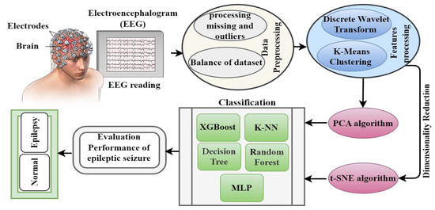

SYSTEM REQUIREMENTS:

HARDWARE REQUIREMENTS:

• System : Pentium IV 2.4 GHz.
• Hard Disk : 40 GB.
• Ram : 512 Mb.

SOFTWARE REQUIREMENTS:

• Operating system : - Windows.
• Coding Language : python.

